Southern cross

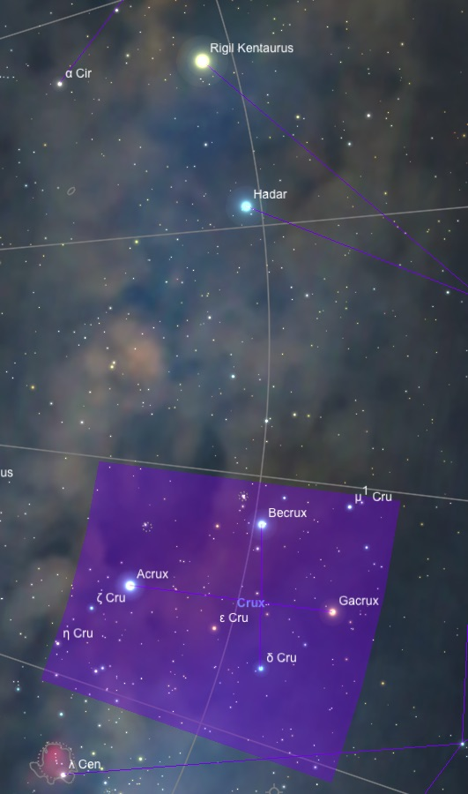

Crux - The Southern Cross
Crux, the Southern Cross, is perhaps the most famous southern constellation. It is the smallest constellation in the sky and covers only 68 square degrees. The Southern Cross points to the South Celestial Pole, in the same way the pointer stars of the Big Dipper point to the North Celestial Pole.

History and Mythology

Crux was considered part of the Centaur's feet in ancient Greek times. However, it was lost to northern inhabitants after precession took it below the European horizon. It took on its own identity in the 15th and 16th centuries, when Christian nations of Europe explored the southern continents. Hundreds of years ago, Crux helped guide early European mariners into the Southern Hemisphere. The long axis of the cross points to the South Celestial Pole, thus indicating the direction toward due south. This constellation was formally named in the 17th century.

Notable Stars
Alpha Crucis is a double star, blue-white in color, with components of magnitude 1.4 and 1.9, separated by 4.4 arcseconds. It is the 14th brightest star in the sky. It is located 320 light-years from our solar system, and composed of two hot blue-white stars with luminosities 25,000 and 16,000 times the Sun's.

Beta Crucis is a blue-white star of magnitude 1.3, and is the 20th brightest star in the sky. It is also a very hot star, with a luminosity of 34,000 Suns, located 350 light-years away.

Gamma Crucis is the third-brightest star in Crux, a red giant of magnitude 1.6. It is 88 light-years away, has a luminosity of 1,500 Suns, and has a white, sixth magnitude companion 25 arcminutes away, which appears to be a physically unrelated star four times more distant.

Clusters, Nebulae, and Galaxies

Crux lies along the southern Milky Way. It is rich in star clusters, and includes the Coalsack dust cloud. NGC 4755 is called the Jewel Box cluster. It contains about 60 stars ranging in magnitude from 6 to 10. The Jewel Box is one of the brightest and youngest clusters known. The stars are mostly supergiants and probably only a few million years old. In a telescope, the Jewel Box is the finest open cluster in the southern skies.

The Jewel Box is near the northern edge of the Coalsack, the most famous dark nebula in the sky. The Coalsack appears as a hole in the Milky Way, where the light from distant stars is obscured. It forms a nearly starless region near the bottom of the cross.

NGC 4052 is an open cluster with stars of eighth magnitude. The open cluster NGC 4103 is made up of some 25 seventh magnitude stars. NGC 4349 is a large, star-colored cluster positioned halfway between Acrux and Epsilon. These clusters, as well as the Jewel Box, can be easily seen with binoculars.

* Alpha1 Crucis, Alpha2 Crucis - Acrux
Acrux is the brightest star in the constellation Crux, the Southern Cross. It lies at the southern end of the long axis of the cross, which points toward the South Celestial Pole.

Acrux is represented in the flags of Australia and New Zealand as one of five stars which comprise the Southern Cross. It is also featured in the flag of Brazil, along with 26 other stars, each of which represents a state; Acrux represents the State of Sao Paulo.

Physical Properties

Acrux is a multiple star located 320 light years from the solar system. Only two components are visually distinguishable, α1 and α2 Cru, separated by 4.4". This pair can be resolved easily in a small telescope.

α1 Cru is magnitude 1.40 and α2 Cru is magnitude 2.09, both hot class B1 V main sequence stars, with surface temperatures of about 28,000 and 26,000 K respectively. Their luminosities are 25,000 and 16,000 times the Sun's. α1 and α2 Cru orbit over such a long period that motion is only barely seen.

* Gamma Crucis
At magnitude 1.59, the reddish star Gamma Crucis is the third-brightest star in constellation Crux. It is one of the four stars in the Southern Cross, and it marks the north end of the asterism. A line through the two "Pointers", α and β Centauri, leads to within a few degrees of this star.

Properties

From a distance of 88 light years, it shines with about 140 times the Sun's visual luminosity, and 1,500 times its total luminosity if infrared radiation is included. The star may be three times the Sun's mass, and as much as 113 times its diameter. It has evolved off of the main sequence to become a red giant, and may even be evolving past the helium-fusing stage.

Companions

Gamma Crucis is a visual double star, with a main sequence companion of spectral class A3 V. The magnitude 6.4 companion star lies 25' away, and can be observed with binoculars. However, the star now appears to be a optical companion, as astronomers now believe that it lies four times farther away from Sol than Gamma Crucis. Note that our Sun, as seen from this companion star, would also appear to be a companion of Gamma Crucis!

